GCP ASSIGNMENT USING TERRAFORM

In this project we are going to use VM machine creation , Loadbalancer creation and GCS bucket creation and last we are going to integret this service. I have give the flow diagram for this project below you can check it.

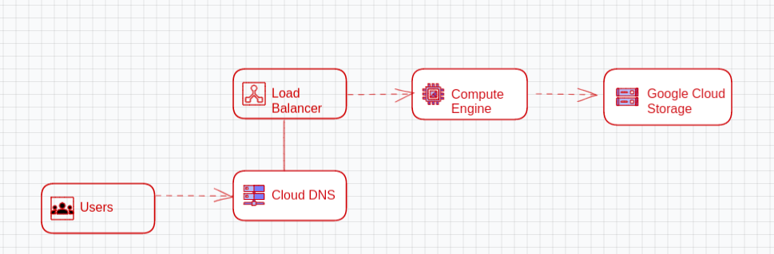
FLOW DIAGRAM :

The above diagram Explain the details of our project how its work. Lets us see steps to create the project using Terraform

Steps 1:
Define your provider: Start by defining the provider you will use. In this case, you'll be using the Google Cloud provider, so you'll add the following code to your configuration file:
provider "google" {
project = "<PROJECT_ID>"
region = "<REGION>"
zone = "<ZONE>"
}

Steps 2:
Create a resource for the VM machine. We need One server HTTP so by using user data we have to install http server in VM machine

resource "google_compute_instance" "my_instance" {
name = "my-instance"
machine_type = "n1-standard-1"
zone = "<ZONE>"
boot_disk {
initialize_params {
image = "<IMAGE_NAME>"
}
}
network_interface {
network = "default"
}
metadata_stsrtup_script = “sudo apt-get update && sudo apt-get install -y apache2”
}

Initialize and apply your Terraform configuration: Run the following command in your terminal to initialize your Terraform configuration:
terraform init
terraform plan
terraform apply

Verify that the VM instance was created: You can verify that the VM instance was created by logging into the Google Cloud Console and checking the Compute Engine instances page.
Steps 3:
Create a Google Cloud Storage bucket: Use the google_storage_bucket resource to create a GCS bucket. Here's an example:
resource "google_storage_bucket" "my_bucket" {
name = "my-bucket"
location = "<REGION>"
force_destroy = true
}
Steps 4:
Upload a file to the bucket: Use the google_storage_bucket_object resource to upload a file to the bucket. Here's an example:
resource "google_storage_bucket_object" "my_object" {
name = "my-file.txt"
bucket = "${google_storage_bucket.my_bucket.name}"
source = "/path/to/local/file.txt"
}
Steps 5:
Attach the bucket to a VM instance: Use the google_compute_instance resource to create a VM instance and attach the GCS bucket to it. Here's an example:
resource "google_compute_instance" "my_instance" {
name = "my-instance"
machine_type = "n1-standard-1"
zone = "<ZONE>"
boot_disk {
initialize_params {
image = "<IMAGE_NAME>"
}
}
network_interface {
network = "default"
}
metadata = {
"google-storage-bucket" = "${google_storage_bucket.my_bucket.name}"
}
}
Initialize and apply your terraform configuration:
terrform init
terraform plan
terraform apply
Verify that the GCS bucket and file were created and attached to the VM instance: You can verify that the GCS bucket and file were created by logging into the Google Cloud Console and checking the Cloud Storage page. You can verify that the bucket is attached to the VM instance by logging into the VM instance and checking the metadata.
Steps 6:
Create a target pool: Use the google_compute_target_pool resource to create a target pool. Here's an example:
resource "google_compute_target_pool" "my_target_pool" {
name = "my-target-pool"
region = "<REGION>"
health_checks = ["<HEALTH_CHECK_NAME>"]
session_affinity = "CLIENT_IP"
instances = ["<VM_INSTANCE_SELF_LINK>"]
}
In this example, you're creating a target pool named "my-target-pool" in the specified region. You're also specifying a health check, session affinity, and the instance that you want to attach to the target pool.

Steps 7:
Create a forwarding rule: Use the google_compute_forward_rule resource to create a forwarding rule. Here's an example:
resource "google_compute_forwarding_rule" "my_forwarding_rule" {
name = "my-forwarding-rule"
target = "${google_compute_target_pool.my_target_pool.self_link}"
ip_address = "<IP_ADDRESS>"
ip_protocol = "TCP"
port_range = "80"
load_balancing_scheme = "EXTERNAL"
}
In this example, you're creating a forwarding rule named "my-forwarding-rule" with a target pool, IP address, protocol, port range, and load balancing scheme.

Initialize and apply your Terraform configuration: Run the following command in your terminal to initialize your Terraform configuration:
terraform init
terraform plan
terraform apply
Verify that the load balancer was created and attached to the VM instance: You can verify that the load balancer was created by logging into the GCP Console and checking the Load Balancing page. You can verify that the load balancer is attached to the VM instance by checking the instance's network tags. The network tags should include the name of the target pool.
Conclusion:
In this session we have detaily discussed about the how to create the VM instance, loadbalancer and GCS bucket .. if the user hit the Loadbalancer user will get the file which will inserted in GCS bucket in Vm machine..

